How to Install & Setup Selenium

1. Download Selenium
   1. The latest version of Selenium can be downloaded from “*http://www.seleniumhq.org/download/*”
   2. Extract the downloaded file and save then into a folder
2. **Download the Selenium Java Client Driver**
   1. You can download the **Selenium Java Client Driver** [*here*](http://seleniumhq.org/download/). You will find client drivers for other languages there, but only choose the one for Java.

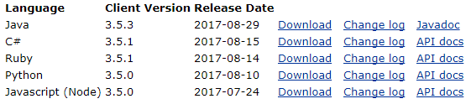

* 1. Create a Java project and include all the downloaded jar files in the build path(In Eclipse IDE).
  2. Now, you are good to start developing Selenium Test cases in Eclipse